**AND GATE**

**2 INPUTS**

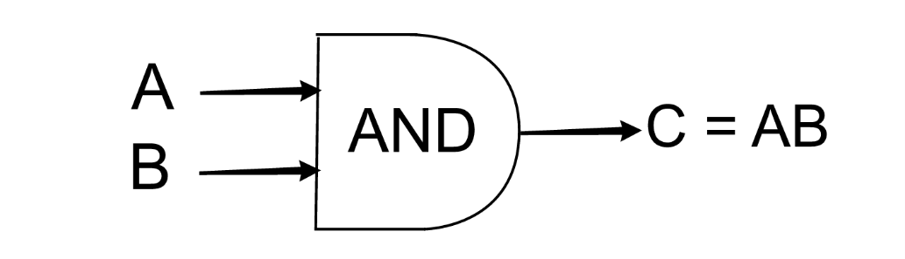

[This Photo](https://courses.lumenlearning.com/suny-hccc-ma-124-1/chapter/putting-it-together-set-theory-and-logic/) by Unknown Author is licensed under [CC BY](https://creativecommons.org/licenses/by/3.0/)

|  |  |  |
| --- | --- | --- |
| **A** | **B** | **C** |
| **0** | **0** | **0** |
| **0** | **1** | **0** |
| **1** | **0** | **1** |
| **1** | **1** | **1** |

**3 INPUTS**

(Stewart, 2024)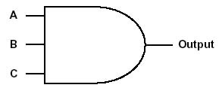

|  |  |  |  |
| --- | --- | --- | --- |
| **A** | **B** | **C** | **OUTPUT** |
| **0** | **0** | **0** | **0** |
| **0** | **0** | **1** | **0** |
| **0** | **1** | **0** | **0** |
| **0** | **1** | **1** | **0** |
| **1** | **0** | **0** | **0** |
| **1** | **0** | **1** | **0** |
| **1** | **1** | **0** | **0** |
| **1** | **1** | **1** | **1** |

**4 INPUTS**

|  |  |  |  |  |
| --- | --- | --- | --- | --- |
| **A** | **B** | **C** | **D** | **OUTPUT** |
| **0** | **0** | **0** | **0** | **0** |
| **0** | **0** | **0** | **1** | **0** |
| **0** | **0** | **1** | **0** | **0** |
| **0** | **0** | **1** | **1** | **0** |
| **0** | **1** | **0** | **0** | **0** |
| **0** | **1** | **0** | **1** | **0** |
| **0** | **1** | **1** | **0** | **0** |
| **0** | **1** | **1** | **1** | **0** |
| **1** | **0** | **0** | **0** | **0** |
| **1** | **0** | **0** | **1** | **0** |
| **1** | **0** | **1** | **0** | **0** |
| **1** | **0** | **1** | **1** | **0** |
| **1** | **1** | **0** | **0** | **0** |
| **1** | **1** | **0** | **1** | **0** |
| **1** | **1** | **1** | **0** | **0** |
| **1** | **1** | **1** | **1** | **1** |